6COSC023W – Final Project Report

Website for the older generation project

Student: Vasileios Protopapas (W1735144)

Supervisor: Panagiotis Chountas

This report is submitted in partial fulfillment of the requirements for the

BSc (Hons) Business Information Systems

at the University of Westminster

School of Computing & Engineering

University of Westminster

Date 28/04/22

**Document Scope**: “The purpose of this document is to describe and reflect on the processes that took place for developing the Final Year Project, discuss any ethical issues associated with it, describe the methodology that was adopted to develop the project, its design, implementation and testing”)

**All chapter word counts in this document are approximate and are not intended to be prescriptive.**

# Declaration

This report has been prepared based on my own work. Where other published and unpublished source materials have been used, these have been acknowledged in references.

Word Count: 7120

Student Name: Vasileios Protopapas

Date of Submission: 11/07/2022

# Abstract

500 words

Summarise here the problem statement and the project aim(s). Provide a brief description of the methodology followed, main results, your conclusions and observations.

My goal would be to help people especially those that have a harder time traversing through the internet such as the older generations or newer users with limited learning resources to gain knowledge and experience in an engaging and meaningful manner so that they can gain independence and integrate themselves in a vastly changing digital landscape. My project aims are to:

1. Provide a learning platform in which the user can interactively learn about how to use the internet
2. Create a user-friendly interface that will accommodate various devices such as mobile platforms
3. Provide a user experience that assists with users that might be visually impaired or in need of auditory feedback
4. Provide users with various mock-ups that simulate different internet inputs such as log ins.

The methodology I followed was the waterfall model which was a UML method which is responsible for dividing all of the specific phases of software development from requirements analysis, system design, implementation, testing, deployment and maintenance. The last stage is not needed for my projects there won’t be any major maintenance however, but the rest of the steps are crucial to my project success.

From all my research I have gathered that the older population have specific preferences when it come to the devices, they will use to access the internet and are unlikely to adapt and learn any new technologies such as, smarts tv’s or smartphones but will use larger screen devices such as laptops and tablets. I had also found out that most elderly people mostly use the internet for online groceries, communication with their relatives and for entertainment purposes.

I have concluded that the elderly has various ways in which they struggle to adapt to the growing digital world but with projects such as my own and other various programmes around, this will help this generation to be able to gain some independence that they might have been unable to get before due to needing additional help from their carers or their younger family members. This will give them the confidence they need in order to help them manage various aspects of their life such as their finances through online banking or accessing their social media.

# Acknowledgements

Thank those you who helped you build your project and supported you during its development, if you wish to here.

# Table of contents

Contents

6COSC023W – Final Project Report 1

Project Title 1

Declaration 3

Abstract 4

Acknowledgements 6

Table of contents 7

List of figures 8

1. Introduction 9

1.1 Problem statement 9

1.2 Delivered Aim and Objectives 9

2. Background 11

2.1 Literature survey 11

2.2 Review of projects / applications 13

2.3 Review of tools and techniques 16

3. Legal, social and ethical issues 19

4. Design 19

5. Methodology 22

6. Tools and implementation 23

6.1 Tools 23

6.2 Implementation 23

7. Testing 34

7.1 Functional testing 34

7.2 User testing 34

8. Conclusions and reflections 36

9. References 38

10. Bibliography 39

Appendix I 39

# List of figures

Provide a list of figures, linking figure numbers to page numbers. If you can, hyperlink the page numbers/figures.

# 1. Introduction

Introduce the project, include the problem statement, project aim(s) and objectives.

## 1.1 Problem statement

500 words

Give some background on the problem/project you intend to solve and the need for the software/application. Use references to support your statements when possible, illustrations, diagrams and figures, if needed.

The purpose for developing this software is to provide a unique learning approach to users that are just beginning to use the internet or want to get a better understanding on how different aspects of the internet works such as online banking, scam prevention and general use of their devices and other potential applications. My goal would be to help people especially those that have a harder time traversing through the internet such as the older generations or newer users with limited learning resources to gain knowledge and experience in an engaging and meaningful manner so that they can gain independence and integrate themselves in a vastly changing digital landscape.

The problem that I want to my project to try and solve is the current and ongoing problems that the older generation of people aged 65 and up are facing when it comes to their technological knowledge. This is especially important currently as during the last 2 years or so with the COVID pandemic there are more people using technology than ever to assist them through all manners such as communication through social media or other methods such as Microsoft teams and zoom, ordering more items online as opposed to going to the store, managing finances a keeping track of all their activities and or hobbies. According to research done by the post office broadband over 39% of over 65s don’t feel confident using a smartphone. This is one of my main concerns and is why I wanted to create a simple and effective website that will teach this specific age group on how to begin to gain more confidence in being able to use said devices as this will help give them the independence that the rest of society currently has but also more importantly to cut down on socially isolated members due to a lack of knowledge with social media.

## 1.2 Delivered Aim and Objectives

200 words

Review the achieved aims and objectives with reference to the ones set in PSPD report.

Comment on the timely completion of the project, use relevant **Gantt charts or other techniques.**

Compared from my previous aims and objectives this didn’t drastically change from the ones from my prototype apart from one aim which was to provide users with various mock-ups of different basic internet functionalities, while the rest of the aims and objectives stayed relatively the same. In the gantt chart below I have shown the time frame that took place after the 23rd of May of each step, and this took approximately 1 month and 10 days to fully integrate test and complete all of the individual slices.

The first part had to mainly do with researching and adding information onto my pages. This took me around 6-7 days to fully complete

After that I went onto the next slice which was to ensure that the size implementations were correct so most of the time this involved testing and researching all the screen resolutions. This took 1 week to complete.

Here I had more implementation that related to the first aim where this is a similar matter where here I have researched information and different techniques, implement them, and then go to the testing phase for each technique then add some more techniques until all of the proposed techniques are complete. This took 2 weeks to complete.

Here I have the mock-up implementation where this took the shortest time to implement and then test to ensure that it all matches up to the all the rest of my pages content and has the learning guides to make it into a learning experience. This took me 1 week and 5 days to complete.

# 2. Background

Review and provide the final findings/ results of a literature survey related to your project subject.

## 2.1 Literature survey

400 words

Describe initial results of a literature survey on a selected research topic or application area related to your project subject. Use relevant books, published research articles as well as Internet content for the purpose. Make use of in-text references to indicate your sources.

The topic that I will be talking about regarding my project will be the inquiry on the elderly access to the internet. This will be in terms of technological accessibility but also through a lens of how the elderly incorporate the internet into their daily lives.

**Device preferences in the elderly**

From my finding I have gathered that the main devices that this age demographic uses are ones which have a larger screen such as a desktop computer, a laptop or a tablet. This is evidenced by Ofcom ., 2020 which mentioned that “However, they exhibited a preference for larger-screen devices; they were more likely than any other age group to use a computer to go online (87%) and just as likely as the average internet user to use a tablet to go online.”. This will make the most sense as the older we get, the more degraded our eyesight will be come, meaning that a larger screen will offer a larger surface area for the person to view the screen contents in a legible manner. The report from Ofcom ., 2020 also mentioned that “Older internet users, aged 65+, were less likely to go online via most devices asked about, and in particular, they were less likely to have adopted smart technology, such as a smartphone, smart TV, or smart speaker.”. This further shows that the elderly will be more likely to use devices with larger screens on them but are less likely to adapt into using more compact technology due to the issues that will arise during daily traversal regarding sight.

**Internet usage in the elderly**

From my research I have found out that how many of the elderly population have some issues with accessing the internet and one of the main reasons to this is from (McGreevy, 2021), “I don’t feel confident learning digital skills, but if someone will show me step by step, I would be willing to learn.” As this shows that most of the older population barriers of entry to the internet mainly consists of having a lack of IT skills (as the graphs show below) this helps give a better purpose to my project as its main purpose is to inform and educate people on the basics of the internet. Most of the elderly population mainly uses the internet for aspects such a online banking, communication through social media and also other day to day stuff such as online shopping.Chart, bar chart

## 2.2 Review of projects / applications

500 words

Describe your background research on existing projects/software/applications and methods/algorithms/techniques relevant to yours, their advantages, and disadvantages. Use illustrations, diagrams, screenshots for the purpose.

You may produce a Table of Features in this section, comparing the main features of the above projects/software/applications and the one you developed.

A comparison table may also be provided to distinguish the key characteristics of features/methods/algorithms/techniques relevant to your project.

During my research I was able to find out about many other websites and apps that have a similar purpose to mine which is to be a learning platform but also some which include teaching the elderly about their online usage. The main one is Age UK as this website specialises in giving advice to the elderly about various subjects and from viewing the website structure this has the most similar layout to my website as this has

|  |  |  |
| --- | --- | --- |
| Table of features | | |
| My project | Other similar projects | |
| Age UK | Duolingo |
| Text to speech | Text to speech | Simple UI |
| Interactive quizzes | Elderly friendly text and layout | Interactive quizzes |
| Image descriptors | Informative topics | Progress tracker |
| Elderly friendly text and colour contrast | Uses html and javascript | Uses Java and C# |
| Uses html and javascript | Mobile friendly | Audio options available |

My own projects interface tabs

Age UK’s own interface tabs

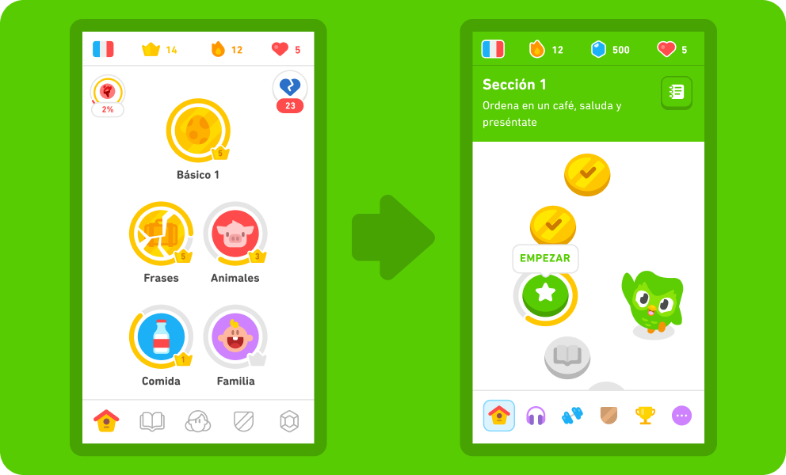

Duolingo’s own interface tabs

From these 3 images we can see that while duolingo’s UI is simplistic, the issue arises when most of the lettering isn’t to a proper size that are required for my projects own target market so mine would be more similar to age Uk’s due to it’s simplicity but also non clashing colours.

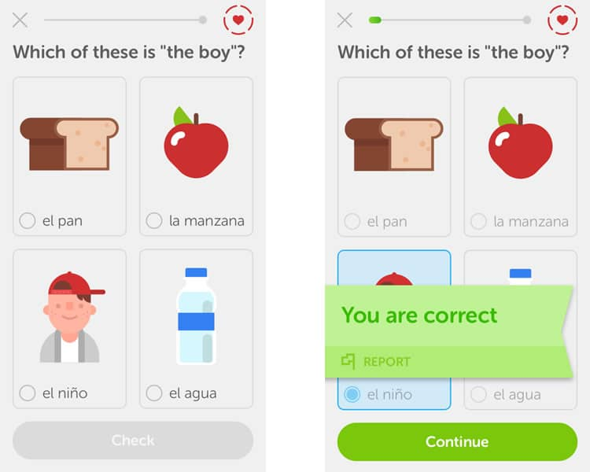

Duolingo own quiz interface

## 2.3 Review of tools and techniques

400 words

Describe results of a survey on relevant tools that can be used to develop applications such as the one you built for your project, such as programming languages and environments, libraries. List their advantages and disadvantages. Use illustrations, diagrams, screen-shots for the purpose.

I have gathered up a survey from a secondary source that encloses the information gathered from over 80000 members on different development languages and the coding environments used most.

(Stack Overflow Developer Survey 2021, 2021)

From these results we can tell that from the sample size that javascript is the most common programming language that is being used by programmers with HTML/CSS only being slightly below it and python third. This means that my project is currently using the most popular programming languages, meaning that there is a better chance of there being loads of documentation that might be necessary if I ever get stuck in one part of my project.

The advantages of javascript are that it is relatively easy to learn compared to other languages such any of the C languages. As mentioned previously due to it’s popularity it also has countless resources in which some one can use to learn JS. It is also very easy to integrate into any website unlike SQL or PHP in which you will have to load up different applications to use them. A final point is that it gives a wide array of options for functionality such as a plethora of options for menu sliders or drag and drop components.

freeCodeCamp.org. 2022.

The disadvantages of javascript are that this is a client-based code, meaning that it can be easily exploitable to many vulnerabilities and bugs that any hacker could use to cause damage to the website.

freeCodeCamp.org. 2022.

The advantages of HTML/CSS are that they have a basic design which can help streamline the process, making it an easy programming language to learn and implement. It is also a very browser friendly website meaning that there won’t be many problems when going from different browsers.

A Plus Topper. 2022.

The disadvantages of HTML/CSS are that to get good functionality out of the code you would need to have extensive lines of code do add something that can be added to other languages in a more efficient way.

A Plus Topper. 2022.

(Stack Overflow Developer Survey 2021, 2021)

Here we can see that the most popular programming environment is visual studio code, with visual studio 2nd and notepad++ third. This means that it would be the most useful if visual studio code is the main environment I use as it will be the one with the most support.

Advantages of visual studio code are that it is easy to understand through its clean ui but also, it’s customisable it can be to suit whichever programming language I am willing to use. It also helps when searching for errors as it will clearly display them and give some help on what went wrong.

Disadvantages of visual studio code are that to change any specific settings isn’t vey intuitive and can be time consuming and it can sometimes be buggy as a program and crash leading to potentially lost work if the program didn’t save it beforehand.

# 3. Legal, social and ethical issues

200 words

Consider any legal, ethical, social, professional and security issues associated with your research and the software/application you are building and/or the data you are collecting/analysing.

Some of the main issues relating with any social, legal, ethical, professional and security would be for example aspects such as the data protection act as I would have a responsibility once a user has put their name and email into my system, I will have their details. I will have to ensure that all their data is kept safe.

Another issue can be that I don’t use any copyrighted material as in accordance with the copyright, designs and patents act of 1988 as I will have many researched topics upon my project. Proper referencing will be displayed upon the website.

I would also have to consider the laws of ux which is “is a collection of best practices that designers can consider when building user interfaces.”. This is because my website has one main forefront on being user accessible so I would have to consider all possible routes to ensure that all of my users need are met so by such as the most readable fonts and sizes, responsive website layout for mobile devices and also colour contrasting that doesn’t clash with the rest of the page diverting attention away from the main object at hand.

# 4. Design

Review and provide your final system design related to your prototype and the final list of requirements. Explain if system requirements are different from the ones defined in PSDP and the initial design.

Discuss how the proposed project design will be implemented and the tools you will be using for doing so.

800 Words

Since my prototype I had to overview all the main functionality of my project and how this would have worked for and comparing from the prototype phase I have now a complete set of all my new requirements. These have been gathered through all of my research done but also through the testing that I have completed from getting user feedback which finalised all of the requirements and this led to somewhat modifying them compared to my prototype.

Functional Requirements

* The system must allow the user to receive an audio interface before clicking on a button.
* The system must allow the user to submit feedback through a contact form in the app.
* The user shall be able to have a variety of interactivity with every page in the website.
* The user should be able to have demos that they can interact with before they go onto the next topic.
* The user should be able to choose between 3 different levels of complexity at the start.

Non-functional requirements

* When the user hovers/goes over a button and a Text to Speech audio will play and describe its function to said user.
* When the submit button is pressed there will be a conformation screen that will pop up on the screen immediately.
* When the user clicks on the take a screenshot button the system will get a picture of their page so that the user can save this to their computer.
* An interactive presentation will include a demo of a log in page and the system will simulate that environment for the user to complete
* The website will be compatible with most mobile and desktop screens and sizes.
* The system should be able to have interactive elements to each article, with text to speech audio, simplified fonts, and quizzes.

Jama Software. n.d

My system requirements have changed since the previous ones described in the PSDP for example I no longer will have the tracking platform being set up but also I will no longer provide a log in system for the users to set up as for my target demographic I believe that the need for remembering their login details and passwords might be an unnecessary step for the purpose of this being a simple web platform, so instead I will have a high score system in which users can submit their quiz scores and see how they are progressing. This is also true for the tracking system as I believe that it would be a more effective way to show their progress through the high score system but I will now also provide the user with a way to take a screenshot of their work and save it onto their computer as this will make it easier for the user to remember how they did in the past as this provides them with a visual aid rather than them having to remember their login details and traverse through different menus to reach their previously tracked progress. I have also decided to add more complexity to my quizzes as they are the main centrepiece of the website, so I decided to have a screenshot option as well as a high score option which will let the user save their latest high score and display it before and after starting a quiz. This quiz will also have the Text to speech options. Instead of the login system I will use this as a learning guide and use it as a mockup to teach the users of all the basics for logging into any website.

My proposed project design will be implemented by using tools such as visual studio code which will be the main base in where I will code the entirety of my project, I will use browsers such as chrome and Firefox as well as their respective mobile phone platform testing which will help with additional testing when changing over to mobile platforms so that this meets with my initial project design. I will implement these features by using a mixture of javascript, html5,css and jquery.

# 5. Methodology

Describe fully the methodologies, processes, and development techniques you followed to assist the design and development of the software/application. 600 Words

The development techniques that I used for my projects mainly consisted of UML as I had used this to show how my initial project will operate through object-oriented design for example, I needed to see how the basic outline of the project will operate through a step-by-step basis and there had to be more than one once I had changed my requirements to match my project design. I didn’t implement SSADM due to the amount of analysis needed to find out the most suitable model for my system, meaning that it would have led me to overanalyse certain aspects of my project which would have been fairly time consuming in a project where this was a crucial aspect. However, I did use Soft Systems as this helped me with developing a rich picture when going through the testing for my project but also through all the necessary research as this was needed to plan through the next stage of development and what aspects I needed to research to ensure that my project stays on track. I also had used some data flow diagrams in a similar way in which I had implemented the UML techniques as both were used to plan my project to check on how in a step-by-step process on how a user will go through my website.

I had used the conventional waterfall development model as the core design of my project is staying the same and there will be a very small chance of any issues that may be changed in the final project but also due to its step-by-step process which suits the way my project operates as that is also sorted by different stages of development as it involves going through gathering requirements which was the first step of my project where I gathered from research how to formulate them, then I used the system design process which helped me in finding the most suitable platforms in which I can use to go through with the next stage which is the implementation stage. Here is where I was working on slices of my project at a given time. Next comes through the integration and testing phase which is where I have the testing phase of my project in which thereafter, I would have to integrate all of my implemented parts of my project and once I have completed each slice, then we go to the system deployment which ends the project development cycle as there won’t be any necessary maintenance for this current project.

The methodologies I used we incremental as when I was finishing one part of my project, I then continued onto the next step essentially going through the project in slices as I mentioned before hand that the waterfall model is what I used and that also goes through a similar stage of development. If I had to choose a hybrid methodology it would be incremental and iterative as this will complement the waterfall model in a very suitable manner as it combines both doing the project in increments but also in iterations which would bolster the path of development as I will be constantly testing my website but also still be developing my projects in slices.

# 6. Tools and implementation

## 6.1 Tools

300 words

The tools that I used to construct my project will be visual studio code which was my main user interface in which I was able to program my project. I used this programming environment because I was able to categorise all the different parts of my project into one interface without needing a new program when I needed to change to another programming language but also it offered a feature where I could see all the changes being made in real time to ensure if there was any need for any corrections.

The main programming languages I used were JavaScript, html5 and css3. I used these languages as it was crucial to the main parts of my website, specifically javascript and jquery with it needed to operate with all the interactivity for my project and the quizzes throughout my project.

Some of the current skills that I had were my programming skills, however as I was progressing through with the project, I was able to further improve upon these skills as I needed to deepen my understanding with parts of the project in which I didn’t have any experience in such as my login system. Another skill I needed to employ when developing on my project was my problem-solving and risk management skills as I have had to see all the errors that were developing in my project and find possible solutions to ensure that they met with my project’s requirements. Graphic design was a new talent I learned because I hadn't previously considered this component of my profession. The main goal of this website was to create a minimal but straightforward interface so that consumers wouldn't be overwhelmed or turned off by the site's design choices.

## 6.2 Implementation

1700 words

Explain implementation of main code for key functions, indicate any novel code clearly and code that is adopted/adapted and the original sources.

Demonstrate that the carried-out implementation clearly mirrors the Design specification as identified during the requirements capture phases

In this section of code, I am showing the functionality behind the text to speech audio that will say out loud all the text that is available at a specific part of the page. From the first part of the code here we are initialising all the necessary parameters mainly play, pause, and stop. In this example the text to the speech synthesis utterance (this is a web API) will gather all text from the article tag and give an audio queue once the playEle button is clicked.

Here we also have the pause and the stop buttons, which function in a similar manner to the play button, however here we have the resume to unpause, pause to pause the tts when the audio is currently playing and cancel which will terminate the audio if there is any speaking currently ongoing.

In this section of the code, I am showing all of the necessary code that is required for the quiz portions of my website

Here we have

Here we have the progress bar which I created in order to give a visual aid to each of the users

Here we have the results screen in which the code will see whether or not they’ve answered the questions correctly and will display to those corresponding results.

Here we have the actual questions set up with their answers in the end and the last line will create the actual quiz and populate the currently empty multiple choice fields.

Here we have the code for the login page which will ensure that the user will have to enter a specific amount to pass through

Here I have the jquery validation code that will take care of the login page which will ensure that every time you fill the field in an invalid way, then it will say to the user to try it again.

Here I am showing the code to ensure that the pages will change their resolution and size content to show how they changed to a different device

Here I am showing the beginning of my code for my presentation page which is a 3-page slideshow which is where the interactive aspect of my website goes over from.

Here we have the code that will make sure that the animation will work as planned for the powerpoint which will gather up the information from the css code and implement it into

This is the second text to speech code, this is for the purpose of having buttons give additional auditorial pointers. I found this code from mozillas own documentation regarding text to speech with speechSynthesisUtterance.

Here I have the button will get the user back to the top of their page this will add additional functionality so that the user doesn’t need to scroll all the way back to the top. I got this code from w3schools

Here I also have my screenshot option for my project which will take a picture of the page and will give the user the ability to save it. I got this from the html2canvas documentation.

This is the main body that will take place from most of my pages (apart from the powerpoint presentations) this ensures that there is a unified design to my website but also that the font size and family are as they are supposed to be to ensure their accessibility.

# All the implementations that are listed above have all met my requirements and project design as they all have the interactivity that I was planning for, the demos are there as they should be, the accessibility options are all as they should be (tts, button to the top, larger alt tabs for the visually impaired and having descriptors for the images using jquery dialogue box, the tts buttons). Also all of the visuals don’t have contrasting colours and the font sizes and styles are easily readable and legible.7. Testing

## 7.1 Functional testing

500 words

Discuss black box or/and white box testing.

As mentioned by jain, m., 2020. Black box testing is:” is a software testing method in which the internal structure/ design/ implementation of the item being tested is not known to the tester”, while white box testing is “is a software testing method in which the internal structure/design/ implementation of the item being tested is known to the tester. jain, m., 2020.

From these definitions I can gather that white box testing is competed by the software developers to test out different aspects of the product that the users wouldn’t be looking for such as the internal mechanisms of the website such as finding loops or seeing that the code and its structure are functioning as they should do. Black box testing will be crucial for functioning testing where the users will test the website to see how it externally operates and will help me see how it coincides with my user requirements.

The method I have used was a black box texting environment as I relied on my testers to not know much about my project or how it operates. This helped my see if my testers would be able to give me feedback on any aspect of my projects that I could have missed beforehand and if there is any time then would have implemented this onto my project.

## 7.2 User testing

500 words

Discuss how you obtained used feedback, using expert or/and non-expert users.

I had obtained user feedback by asking permission from my parents and a few adjacent family members, mainly those over the age of 50 to show my websites functionality but also to see if my website is intuitive to use for my main target audience. I made them go through the website as if they would have been using it normally as this will give me an idea of how a non expert user would use the website. I asked them a series of questions based on their time with my project these questions included:

* Could you use the website with ease? (i.e. Could traverse it with one finger)
* Are the visual queues helpful in pointing out the content shown on the page?
* Did you find the use of text to speech to be useful or not?
* Did the quizzes feel relevant to the given topic at hand?
* Does the website comfortably scale down to tablets?
* Were the topics engaging to learn through?
* From a scale of 1-10 how visually appealing is the website?
* Anything you think that can be improved for the website?

These questions covered a good portion of all the main aspects of my website and the feedback that I have received from them has been most helpful in trying to improve my project further as the feedback I received would have been objective due to them needing to engage with the entire website. Once I had incorporated that feedback to my project, I would ask them to once more test my website to see if there have been any improvements or whether I needed to go back to change aspects of my project that would cause to enhance the user’s experience.

Another form of testing I did was to compare certain parts of my functionality to other similar websites to see whether they are working as intended and if I find out that there are some bugs or inconsistencies with my code, then I would see to it that it gets fixed. For this I also used code validators to ensure that my coding is meets the specific set of rules so that there are little errors that will occur from my code. If an error is found then it would be changed until it’s entirely valid but also performs to a similar level than those that I have compared it to.

# 8. Conclusions and reflections

1000 words

Include conclusions on the resulting application/research, reflect on strengths and weaknesses, discuss the acquisition of any new knowledge and skills and consider further work.

In conclusion I believe that from all the research gathered that I have reached a good understanding on how the older populations use online platforms in their everyday life and how my project will help give them a better understanding on how they can traverse the digital world to help further improve their quality of life. I had also learned a lot about all the additional measures that the older population needs to ensure that the websites and apps they will use will be as accessible as possible so that there are less barriers of entry to that population. For example, text to speech was very crucial to my project as this gives access to all users with visual impairments and how text and colours are viewed by older people as they might need some more visual queues such as larger text sizes and a more readable font but also colours that don’t contrast with each other as this might make it harder distinguish between all the different aspects of the page. One final aspect I learned was on how I could make my website more accessible by also making it mobile friendly as I had previously found out from my research that older generation will use devices that have larger screens such as tablets and laptops, meaning that I have used my knowledge in the media tag from css which will adjust the screen size according to the screen resolution, however I have also included options for mobile devices as one of my main goals is to ensure that as many people will be able to use my website as possible. This ensures that while the user is scrolling down through their phone all of the page contents will have been neatly organised so that it will reduce the chances of having to use multiple fingers to traverse through the website without disadvantaging my target group who can include having arthritis especially in the hands (also found out from my research).

Some of my strengths were that I was able to use my current programming knowledge to solve many obstacles that I faced during the production of my project, such as having prior knowledge on how to create a quiz but also being able to implement text to speech on every aspect that can help the users. Another strength I have was that I was able to meet all of my design specifications and aims that I had set out to do as I when was getting my feedback from my testing, they seemed to have been positive and would have been more inclined to use my project in the future for their learning opportunities. One final strength I had was my organisation skills as I was able to mitigate different design specifications to different weeks during the month but also in ensuring that if I overestimated my skills I would have been able to downscale my project to still meet my aims and objectives.

With some of my weaknesses in this project being able to ensure that time management was of the upmost importance as I this had set me back in some departments which needed more time than I had anticipated meaning that i was behind on the entire project causing me to have to spend more time later which I had to develop other parts of the project. This meant that my project has been left underdeveloped in aspects such as the UI which while is basic and serviceable, they might not be as visually polished as a more professional website.

As mentioned previously my newfound skills and knowledge were how to adapt to using new programming languages that I had previously little knowledge in such as further developing my jquery skills as previously I only had a very basic understanding on how I was able to implement it to my project beforehand but now I was able to incorporate it into various aspects of my projects such as my popup information tags. This helped making my code more efficient as there was less lines of code needed to complete the same task on javascript. I have also learned more about how CSS is used to ensure that the website will be as accessible as possible by using various parts such as different font families, font sizes, ensuring that all contents of the page neatly change resolutions according to the specified screen size which are media buttons. This has also given me better communications skills during the testing period as I was able to clearly communicate with my testers on how many changes needed to happen to my project but also planning to use the necessary questions so that they coincide with my my design specifications and plans.

In the future if I were to improve upon this project, I would ensure that my user interface have better amounts of polish so that they can look at their most presentable to the users, I would also have ensured that next time I would have managed my time better in order to not have the need to cut any content that might have further enhanced my project and thereby the users learning as if I had the login system as a genuine one then they would have had better knowledge on how login systems work by having a better hands on approach to than just having a demonstration given to them. I would have also ensured that my code was more efficient as there are some aspects in which there may be line of unnecessary code than could have been shortened by having a further understanding of jquery but also more DOM commands which would have sped up my websites during the quiz portions. One final aspect I would have considered would have been to have done more primary research so that I could better understand how my potential target market as most of the secondary research I have gathered gave me a good idea of all the issues I could face but also having more up to date data.

# 9. References

Include a list of cited in your text items (books, papers, websites, etc.). Use Harvard style for the purpose, or any other preferred standard referencing style.

1. jain, m., 2020. Differences between Black Box Testing vs White Box Testing - GeeksforGeeks. [online] GeeksforGeeks. Available at: <https://www.geeksforgeeks.org/differences-between-black-box-testing-vs-white-box-testing/> [Accessed 19 April 2022].
2. Ofcom ., 2020.[online] Available at: <https://www.ofcom.org.uk/__data/assets/pdf_file/0025/217834/adults-media-use-and-attitudes-report-2020-21.pdf> [Accessed 9 July 2022].
3. Stack Overflow. 2021. Stack Overflow Developer Survey 2021. [online] Available at: <https://insights.stackoverflow.com/survey/2021#overview> [Accessed 9 July 2022].
4. McGreevy, H., 2021. Almost half of Londoners over 75 do not use the internet, Age UK London study reveals. [online] South West Londoner. Available at: <https://www.swlondoner.co.uk/news/24082021-almost-half-of-londoners-over-75-do-not-use-the-internet-age-uk-study-reveals> [Accessed 9 July 2022].

# 10. Bibliography

Include here a list of general reading items (books, papers, websites, etc.). List the items in alphabetical order, using Harvard style to describe them.

* A Plus Topper. 2022. Advantages And Disadvantages Of HTML | What is HTML?, Top 5 HTML Advantages and Disadvantages. [online] Available at: <https://www.aplustopper.com/advantages-and-disadvantages-of-html/> [Accessed 9 July 2022].
* freeCodeCamp.org. 2022. The Advantages and Disadvantages of JavaScript. [online] Available at: <https://www.freecodecamp.org/news/the-advantages-and-disadvantages-of-javascript/> [Accessed 9 July 2022].
* Jama Software. n.d. Functional requirements examples and templates – JamaSoftware.[online]Available at: <https://www.jamasoftware.com/requirements-management-guide/writing-requirements/functional-requirements-examples-and-templates>

# Appendix I

Provide additional material, if appropriate, in separate appendices.

Use one Appendix to provide a link to an on-line video demo of the project.

Do not include the entire code in print as an appendix.

A new skill that I developed was graphic design as previously I wasn’t considering this aspect upon my work as and with the main purpose of this website was for it to be a simple but intuitive interface so that the users wouldn’t feel overwhelmed or put off by the websites specific interface choices.